**Car Sales Analysis MySQL QUERY DOCUMENT**

**Car Sales Analysis| SUMMARY : BY Shivanand S Nashi**

**1. Create a Database Carsales**

**This creates a new database named Carsales in MySQL.**

**Create database Carsales;**

**if the database doesn’t exist**

**CREATE DATABASE IF NOT EXISTS Carsales;**

**2. Select the Carsales Database**

**use Carsales;**

**3. Show All Tables in the Database**

**This lists all tables present in the Carsales database.**

**SHOW TABLES;**

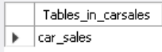

**4. Describe the Car_Sales Table Structure**

**This shows the columns, data types, keys, and constraints of the Car_Sales table.**

**describe Car_Sales ;**

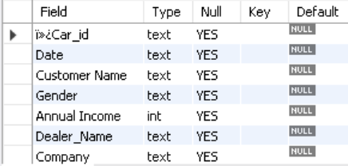

**5. Retrieve All Data from Car_Sales**

**This selects all rows and columns from the Car_Sales table.**

**select * from car_sales;**

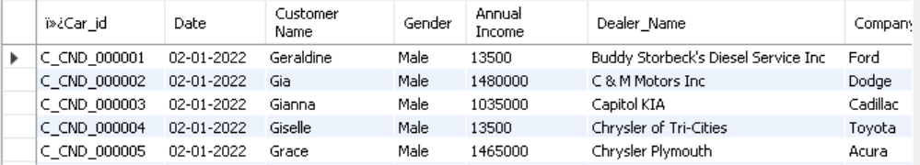

**6. Count the Total Number of Rows in Car_Sales**

**This returns the total number of records (rows) in the table.**

**select count(*) from car_sales;**

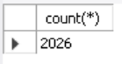

**7. Retrieve Customer Names Who Bought a Ford Car**

**SELECT `Customer Name` FROM Car_Sales**

**WHERE company = 'Ford' ORDER BY `Customer Name`;**

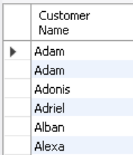

**-- check how many gendercar_sales--**

**select distinct(gender) from car_sales;**

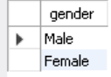

**-- Sales Performance Analysis--**

**1.What is the total revenue generated by each dealer?**

**SELECT Dealer_Name, SUM(`Price ($)`) AS total_revenue**

**FROM car_sales GROUP BY Dealer_Name ORDER BY total_revenue DESC**

**LIMIT 1000;**

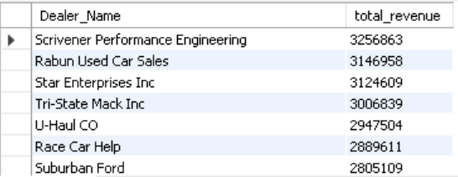

**2.Which dealer has the highest number of sales?**

**select Dealer_Name, count(ï»¿Car_id) as number_of_order**

**from Car_sales group by Dealer_Name order by number_of_order desc limit 6;**

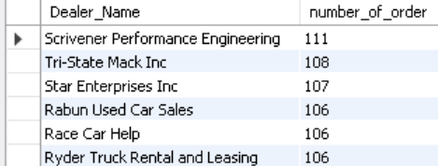

**3.What is the average price of cars sold by each dealer?**

**SELECT Dealer_Name, CAST(AVG(`Price ($)`) AS UNSIGNED) AS average_price**

**FROM Car_sales GROUP BY Dealer_Name ORDER BY average_price DESC;**

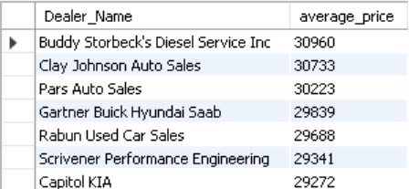

**-- Customer Demographics and Behavior--**

**1.What is the gender distribution of customers?**

**select gender , count(gender) as number_gender**

**from car_sales group by gender order by number_gender desc;**

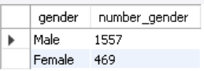

**2.What is the average annual income of customers?**

**SELECT `Customer Name`, CAST(AVG(`Annual Income`) AS UNSIGNED) AS avg_annual_income FROM car_sales GROUP BY `Customer Name` ORDER BY avg_annual_income DESC;**

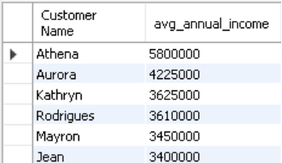

**3.What is the distribution of customers based on the dealer regions?**

**select Dealer_Region as region, count(Dealer_Region) as customers_regions**

**from Car_Sales group by region order by customers_regions desc;**

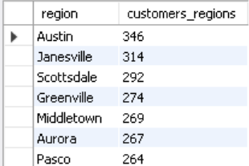

**-- Model and Company Insights--**

**1.What are the top 5 most popular car models?**

**select model, count(ï»¿Car_id) as number_of_sales**

**from Car_Sales group by model order by number_of_sales desc limit 5;**

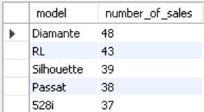

**2.Which company has the highest sales volume?**

**select company, count(ï»¿Car_id) as sales_volume**

**from car_sales group by company order by sales_volume desc limit 5;**

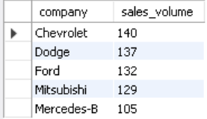

**3.What is the average price of cars from each company?**

**select company , cast(avg(`Price ($)`) as decimal(5,2) )as average_price**

**from car_sales group by company order by average_price desc;**

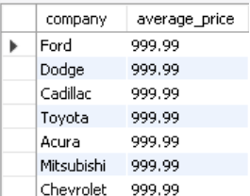

**SELECT company, CAST(AVG(`Price ($)`) AS UNSIGNED) AS average_price**

**FROM Car_Sales GROUP BY company ORDER BY average_price DESC;**

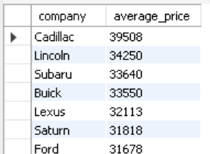

**-- Regional Analysis--**

**1.Which dealer region has the highest sales revenue?**

**select dealer_region, count(ï»¿Car_id) as sales_volume**

**from car_sales group by dealer_regionorder by sales_volume desc limit 1 offset 0;**

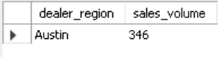

**2.Which dealer region has the 2nd highest sales revenue?**

**select dealer_region, count(ï»¿Car_id) as sales_volume**

**from car_sales group by dealer_region order by sales_volume desc limit 1 offset 1;**

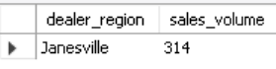

**3.What is the sales performance comparison between different dealer regions?**

**select dealer_region,sum(`Price ($)`) as total_sales,round(avg(`Price ($)`)) as avg_sales,**

**count(ï»¿Car_id) as no_of_sales from car_sales group by dealer_region order by total_sales desc;**

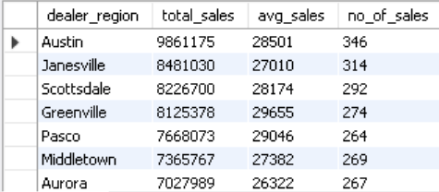

**4.How does the average car price vary across different regions?**

**select dealer_region as region, round(avg(`Price ($)`)) as avg_price**

**from car_sales group by region order by avg_price desc;**

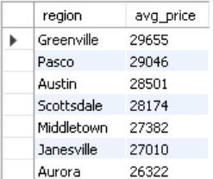

**-- Engine and Transmission Preferences--**

**select distinct(engine) from car_sales;**

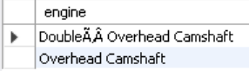

**1.What is the distribution of engine types among sold cars?**

**select engine as Engine_Type,count(ï»¿Car_id) as number_of_car_sold**

**from car_sales group by Engine_Type order by number_of_car_sold desc;**

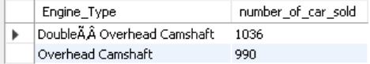

**2.What percentage of cars sold have automatic vs. manual transmission?**

**SELECT TRANSMISSION , COUNTS ,**

**(COUNTS *100.0 / (SELECT COUNT(*) FROM CAR_SALES) ) AS PERCENTAGE**

**FROM(**

**SELECT TRANSMISSION , COUNT(TRANSMISSION) COUNTS**

**FROM CAR_SALES**

**GROUP BY TRANSMISSION ORDER BY COUNTS DESC**

**) AS TRAN;**

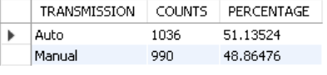

**-- Color and Body Style Trends--**

**1.What are the top 3 most popular car colours?**

**SELECT COLOR , COUNT(ï»¿Car_id) AS POPULAR_SALES**

**FROM CAR_SALES GROUP BY COLOR ORDER BY POPULAR_SALES DESC LIMIT 3;**

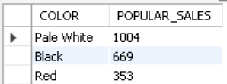

**2.What is the distribution of body styles among sold cars?**

**SELECT 'Body Style' , COUNT(ï»¿Car_id) AS SOLD_CARS**

**FROM CAR_SALES GROUP BY 'Body Style' ORDER BY SOLD_CARS DESC;**

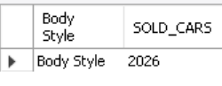

**-- Dealer Performance--**

**1.What is the total number of sales made by each dealer?**

**SELECT DEALER_NAME, COUNT(ï»¿Car_id) NO_OF_SALES**

**FROM CAR_SALES GROUP BY DEALER_NAME ORDER BY NO_OF_SALES DESC;**

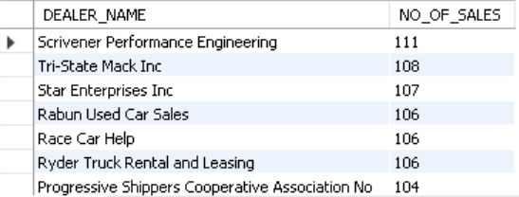

**2.Which dealer has the highest average sales price?**

**SELECT DEALER_NAME, ROUND(AVG(`Price ($)`)) AS AVG_PRICE**

**FROM CAR_SALES GROUP BY DEALER_NAME ORDER BY AVG_PRICE DESC**

**LIMIT 1;**

